ARTIFICIAL INTELLIGENCE LAB REPORT
CSA17 – Artificial Intelligence
SIMATS Engineering
Computer Science and Engineering

1. Python program to solve 8-Puzzle problem

Aim
To solve the 8-Puzzle problem by finding a sequence of moves from the initial state to the goal state.

Algorithm
- Represent the board as a 3×3 state.
- Find the blank tile and generate valid moves.
- Evaluate generated states using a search strategy.
- Avoid repeated states.
- Continue until the goal state is reached and display the solution path.

Pseudocode
START
Represent the board as a 3×3 state.
Find the blank tile and generate valid moves.
Evaluate generated states using a search strategy.
Avoid repeated states.
Continue until the goal state is reached and display the solution path.
DISPLAY the required result
STOP

Input
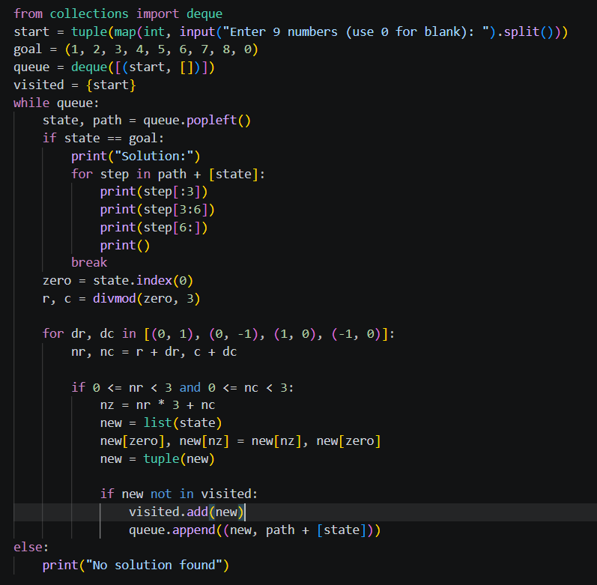
Output
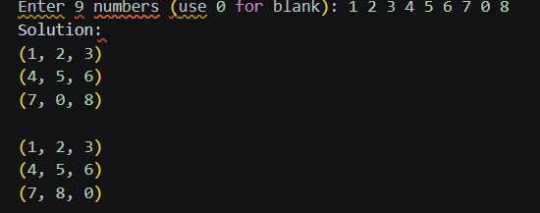

Result
The python program to solve 8-puzzle problem was successfully designed as per the stated objective. The required output can be obtained by executing the corresponding program with valid input.

2. Python program to solve 8-Queen problem

Aim
To solve the 8-Queens problem by placing eight queens on a chessboard so that no two queens attack each other.

Algorithm
- Place queens row by row.
- Check column and diagonal safety.
- If safe, place the queen and continue.
- If no safe position exists, backtrack.
- Stop when all eight queens are placed.

Pseudocode
START
Place queens row by row.
Check column and diagonal safety.
If safe, place the queen and continue.
If no safe position exists, backtrack.
Stop when all eight queens are placed.
DISPLAY the required result
STOP
Input
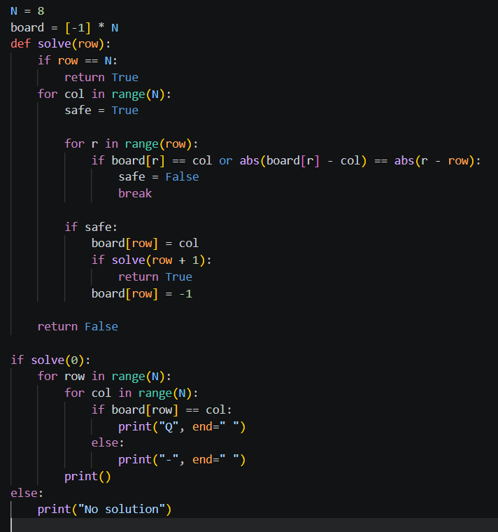
Output
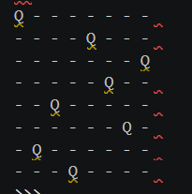

Result
The python program to solve 8-queen problem was successfully designed as per the stated objective. The required output can be obtained by executing the corresponding program with valid input.

3. Python program for Water Jug Problem

Aim
To find a sequence of operations that transfers the required amount of water using available jugs.

Algorithm
- Represent each state by the amounts of water in the jugs.
- Generate fill, empty and pour operations.
- Reject invalid or repeated states.
- Search the state space.
- Stop when the goal quantity is obtained.

Pseudocode
START
Represent each state by the amounts of water in the jugs.
Generate fill, empty and pour operations.
Reject invalid or repeated states.
Search the state space.
Stop when the goal quantity is obtained.
DISPLAY the required result
STOP
Input
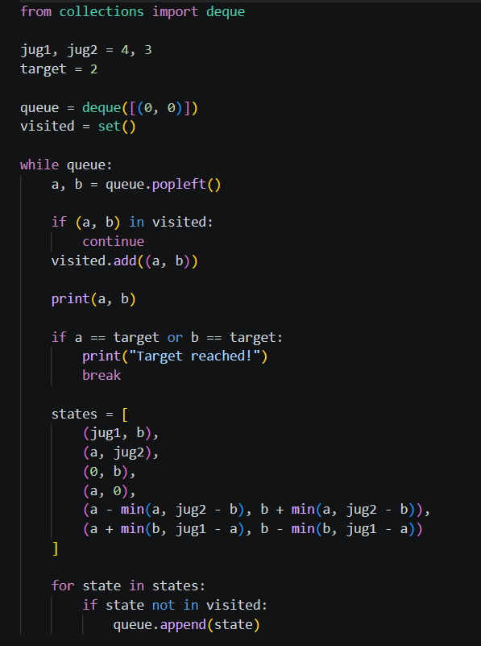

Output
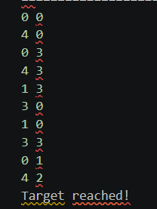

Result
The python program for water jug problem was successfully designed as per the stated objective. The required output can be obtained by executing the corresponding program with valid input.

4. Python program for Crypt-Arithmetic problem

Aim
To solve a crypt-arithmetic puzzle by assigning unique digits to letters.

Algorithm
- Identify all distinct letters.
- Assign digits to letters with no repetition.
- Ensure leading letters are non-zero.
- Evaluate the arithmetic equation.
- Accept assignments that satisfy the equation.

Pseudocode
START
Identify all distinct letters.
Assign digits to letters with no repetition.
Ensure leading letters are non-zero.
Evaluate the arithmetic equation.
Accept assignments that satisfy the equation.
DISPLAY the required result
STOP
Input
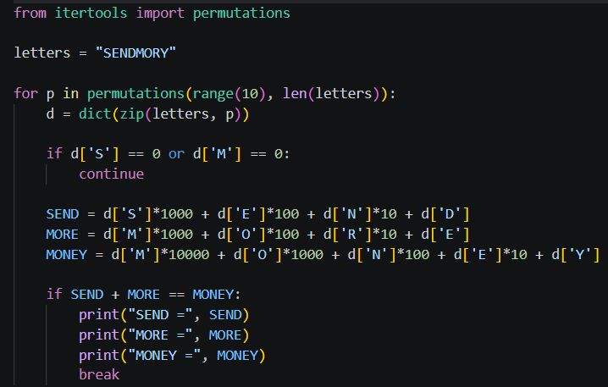
Output
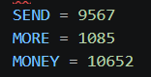

Result
The python program for crypt-arithmetic problem was successfully designed as per the stated objective. The required output can be obtained by executing the corresponding program with valid input.
5. Python program for Missionaries Cannibal problem

Aim
To solve the Missionaries and Cannibals river-crossing problem safely.

Algorithm
- Represent missionaries, cannibals and boat position as a state.
- Generate legal boat moves.
- Reject states where cannibals outnumber missionaries when missionaries are present.
- Avoid repeated states.
- Search until the goal state is reached.

Pseudocode
START
Represent missionaries, cannibals and boat position as a state.
Generate legal boat moves.
Reject states where cannibals outnumber missionaries when missionaries are present.
Avoid repeated states.
Search until the goal state is reached.
DISPLAY the required result
STOP
Input
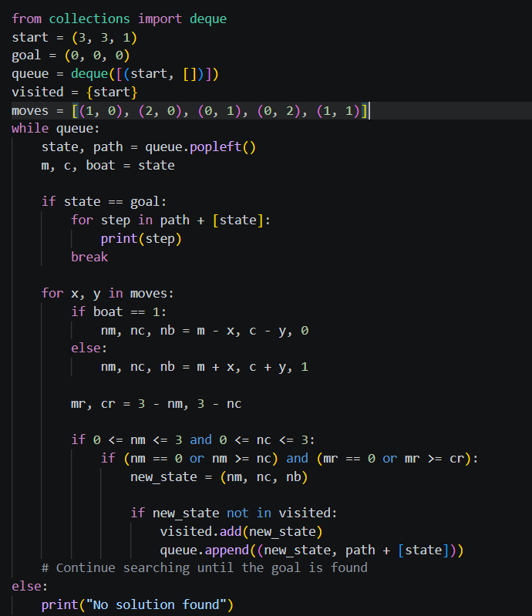

Output
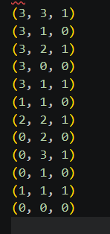

Result
The python program for missionaries cannibal problem was successfully designed as per the stated objective. The required output can be obtained by executing the corresponding program with valid input.

6. Python program for Vacuum Cleaner problem

Aim
To implement the basic Vacuum Cleaner problem using an intelligent agent.

Algorithm
- Represent the current room and cleanliness status.
- Sense the current environment.
- If the current room is dirty, clean it.
- Otherwise move to the required room.
- Repeat until the required rooms are clean.

Pseudocode
START
Represent the current room and cleanliness status.
Sense the current environment.
If the current room is dirty, clean it.
Otherwise move to the required room.
Repeat until the required rooms are clean.
DISPLAY the required result
STOP
Input
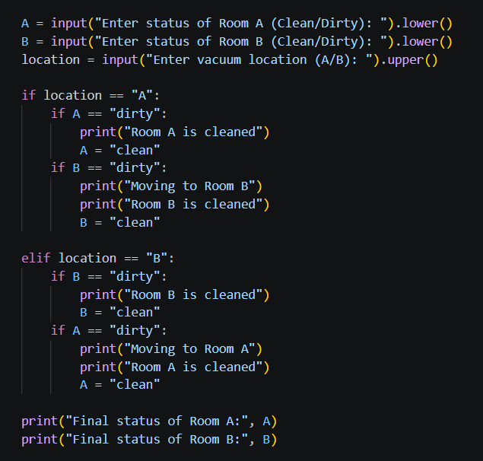

Output

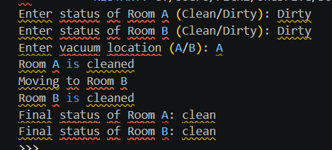

Result
The python program for vacuum cleaner problem was successfully designed as per the stated objective. The required output can be obtained by executing the corresponding program with valid input.

7. Python program to implement BFS

Aim
To traverse a graph using Breadth First Search.

Algorithm
- Start from the selected vertex.
- Insert it into a queue and mark it visited.
- Remove a vertex from the queue.
- Visit and enqueue each unvisited adjacent vertex.
- Continue until the queue becomes empty.

Pseudocode
START
Start from the selected vertex.
Insert it into a queue and mark it visited.
Remove a vertex from the queue.
Visit and enqueue each unvisited adjacent vertex.
Continue until the queue becomes empty.
DISPLAY the required result
STOP
Input
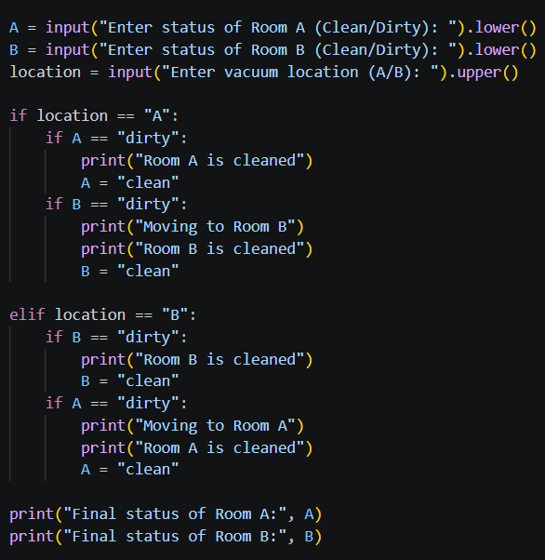

Output

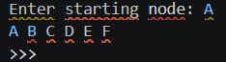

Result
The python program to implement bfs was successfully designed as per the stated objective. The required output can be obtained by executing the corresponding program with valid input.

8. Python program to implement DFS

Aim
To traverse a graph using Depth First Search.

Algorithm
- Start from the selected vertex.
- Mark it visited.
- Visit an unvisited adjacent vertex.
- Continue recursively or with a stack.
- Backtrack when no unvisited adjacent vertex remains.

Pseudocode
START
Start from the selected vertex.
Mark it visited.
Visit an unvisited adjacent vertex.
Continue recursively or with a stack.
Backtrack when no unvisited adjacent vertex remains.
DISPLAY the required result
STOP
Input
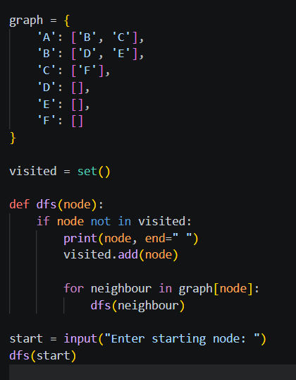

Output

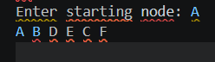

Result
The python program to implement dfs was successfully designed as per the stated objective. The required output can be obtained by executing the corresponding program with valid input.

9. Python program to implement Travelling Salesman Problem

Aim
To find a minimum-cost tour that visits every city exactly once and returns to the starting city.

Algorithm
- Choose a starting city.
- Generate possible next-city choices.
- Build tours without repeating cities.
- Calculate each tour cost.
- Select the tour with minimum total cost.

Pseudocode
START
Choose a starting city.
Generate possible next-city choices.
Build tours without repeating cities.
Calculate each tour cost.
Select the tour with minimum total cost.
DISPLAY the required result
STOP
Input
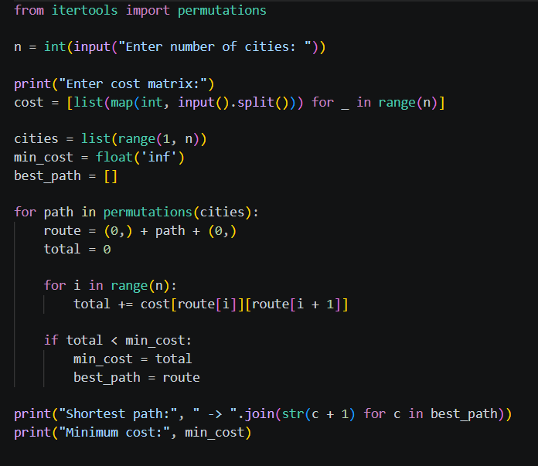
Output
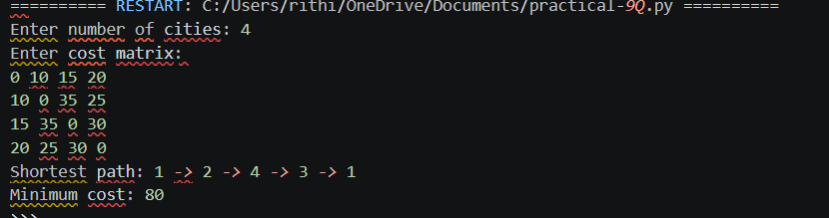

Result
The python program to implement travelling salesman problem was successfully designed as per the stated objective. The required output can be obtained by executing the corresponding program with valid input.

10. Python program to implement A* algorithm

Aim
To find an optimal path from a start node to a goal node using A* search.

Algorithm
- Initialize the start node.
- Calculate f(n)=g(n)+h(n).
- Select the node with the smallest f value.
- Expand its neighbours and update costs.
- Continue until the goal is selected.

Pseudocode
START
Initialize the start node.
Calculate f(n)=g(n)+h(n).
Select the node with the smallest f value.
Expand its neighbours and update costs.
Continue until the goal is selected.
DISPLAY the required result
STOP
Input
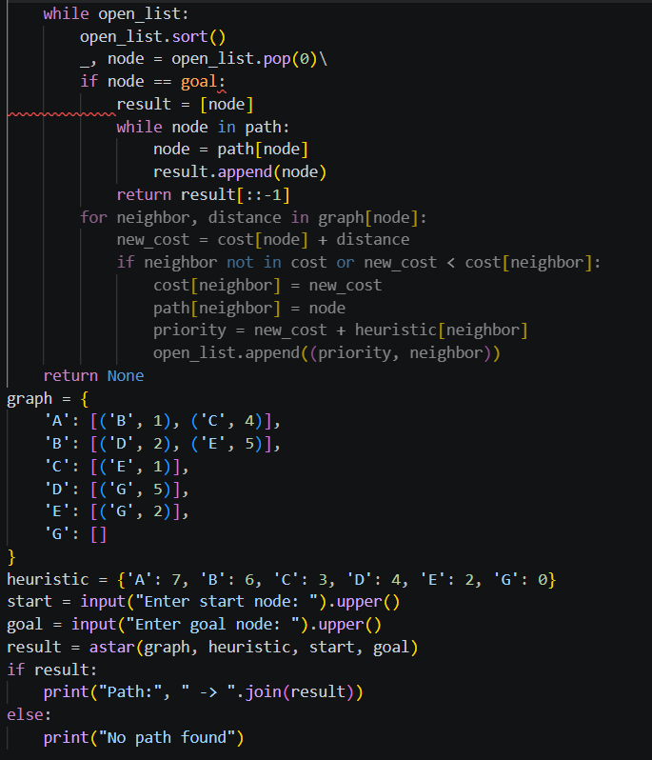

Output
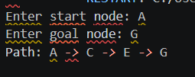

Result
The python program to implement a* algorithm was successfully designed as per the stated objective. The required output can be obtained by executing the corresponding program with valid input.

11. Python program for Map Coloring to implement CSP

Aim
To assign colors to a map so that adjacent regions have different colors.

Algorithm
- Represent regions as variables and adjacency as constraints.
- Select an uncolored region.
- Try an available color.
- Check it against neighboring assignments.
- Backtrack when a conflict occurs and continue until all regions are colored.

Pseudocode
START
Represent regions as variables and adjacency as constraints.
Select an uncolored region.
Try an available color.
Check it against neighboring assignments.
Backtrack when a conflict occurs and continue until all regions are colored.
DISPLAY the required result
STOP

Input

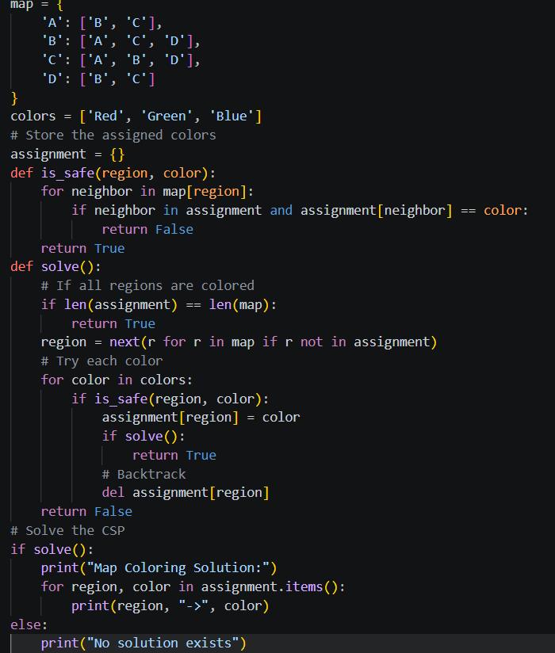

Output

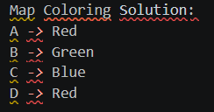

Result
The python program for map coloring to implement csp was successfully designed as per the stated objective. The required output can be obtained by executing the corresponding program with valid input.

12. Python program for Tic Tac Toe game

Aim
To implement a two-player Tic Tac Toe game.

Algorithm
- Create a 3×3 board.
- Accept a valid move from the current player.
- Update the board.
- Check rows, columns and diagonals for a win or check for a draw.
- Switch players and repeat until the game ends.

Pseudocode
START
Create a 3×3 board.
Accept a valid move from the current player.
Update the board.
Check rows, columns and diagonals for a win or check for a draw.
Switch players and repeat until the game ends.
DISPLAY the required result
STOP

Input

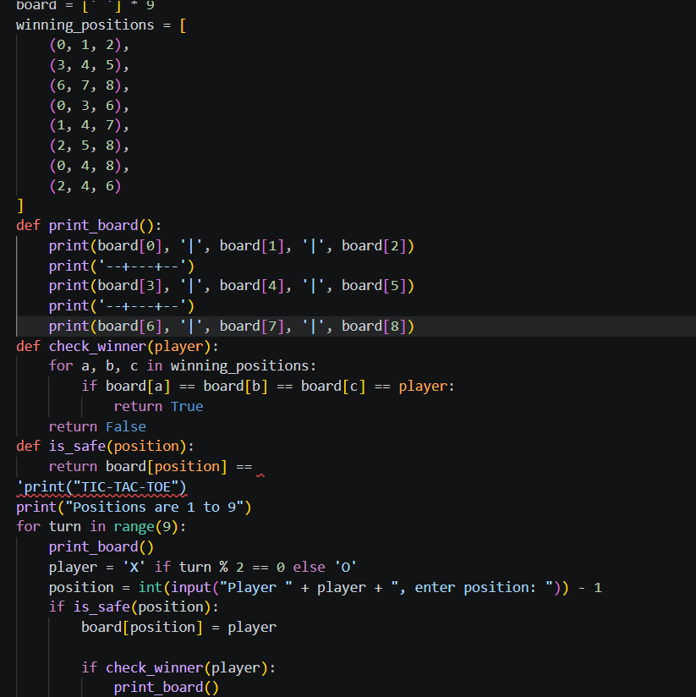

Output

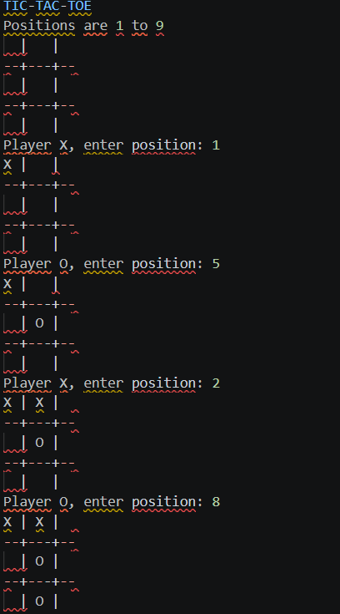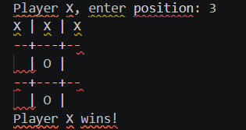

Result
The python program for tic tac toe game was successfully designed as per the stated objective. The required output can be obtained by executing the corresponding program with valid input.

13. Python program to implement Minimax algorithm for gaming

Aim
To select the best move in a two-player game using the Minimax algorithm.

Algorithm
- Generate legal moves.
- Recursively evaluate resulting game states.
- Maximizing player chooses the highest score.
- Minimizing player chooses the lowest score.
- Return the move with the best score.

Pseudocode
START
Generate legal moves.
Recursively evaluate resulting game states.
Maximizing player chooses the highest score.
Minimizing player chooses the lowest score.
Return the move with the best score.
DISPLAY the required result
STOP

Input

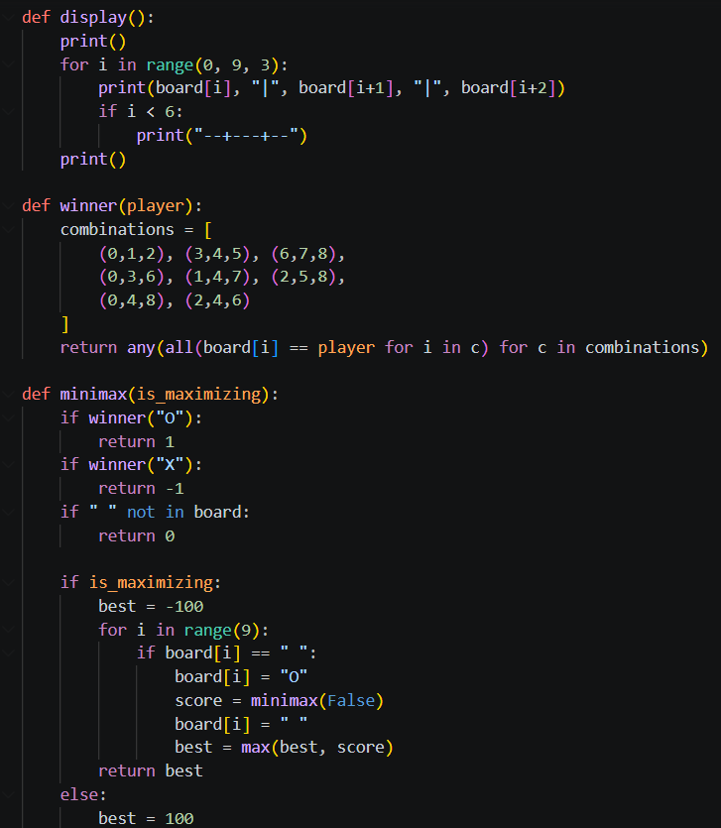

Output

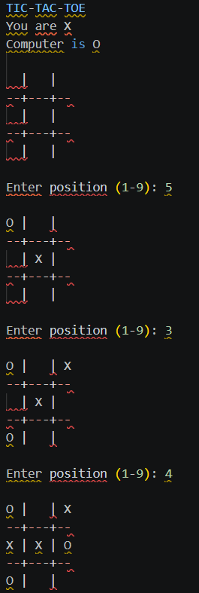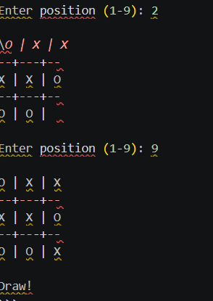

Result
The python program to implement minimax algorithm for gaming was successfully designed as per the stated objective. The required output can be obtained by executing the corresponding program with valid input.

14. Python program to implement Alpha & Beta pruning algorithm for gaming

Aim
To improve Minimax performance by pruning branches that cannot affect the final decision.

Algorithm
- Initialize alpha and beta values.
- Expand game states recursively.
- Update alpha at maximizing nodes and beta at minimizing nodes.
- Prune when alpha is greater than or equal to beta.
- Return the best available move.

Pseudocode
START
Initialize alpha and beta values.
Expand game states recursively.
Update alpha at maximizing nodes and beta at minimizing nodes.
Prune when alpha is greater than or equal to beta.
Return the best available move.
DISPLAY the required result
STOP
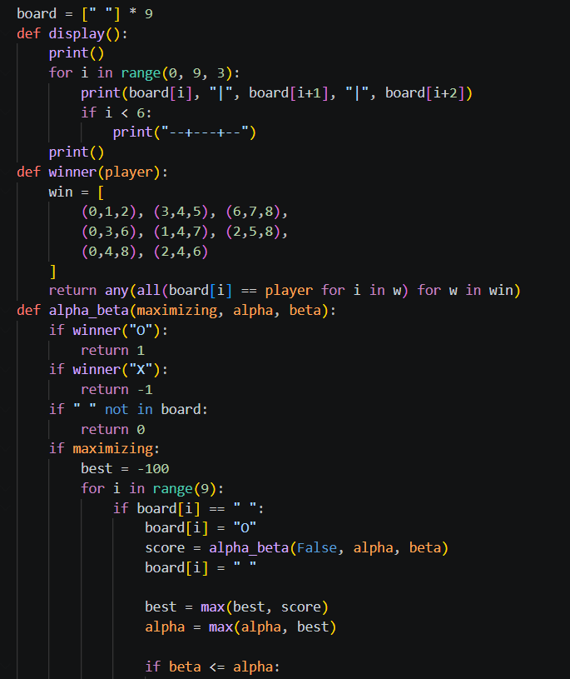
Input

Output

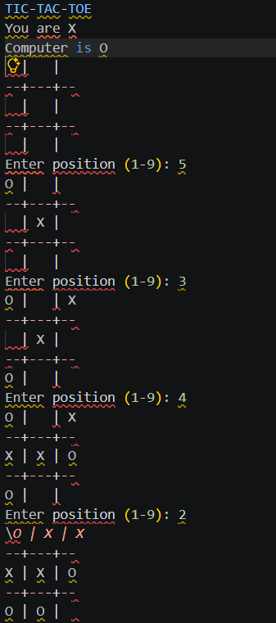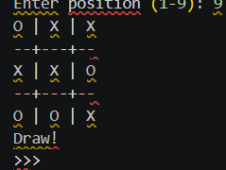

Result
The python program to implement alpha & beta pruning algorithm for gaming was successfully designed as per the stated objective. The required output can be obtained by executing the corresponding program with valid input.

15. Python program to implement Decision Tree

Aim
To classify data using a decision tree.

Algorithm
- Prepare labeled training data.
- Select a useful feature using an impurity measure.
- Split the data into branches.
- Repeat recursively for each branch.
- Stop at suitable leaf nodes and classify new samples.

Pseudocode
START
Prepare labeled training data.
Select a useful feature using an impurity measure.
Split the data into branches.
Repeat recursively for each branch.
Stop at suitable leaf nodes and classify new samples.
DISPLAY the required result
STOP

Input

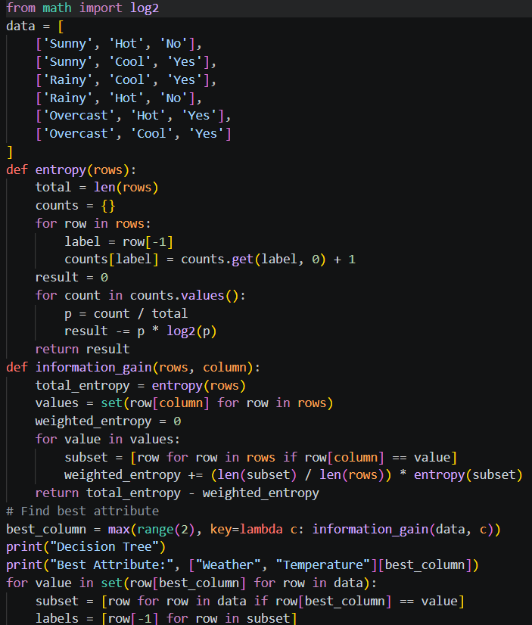

Output

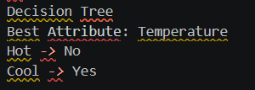

Result
The python program to implement decision tree was successfully designed as per the stated objective. The required output can be obtained by executing the corresponding program with valid input.

16. Python program to implement Feed forward neural Network

Aim
To implement a basic feed-forward neural network.

Algorithm
- Initialize weights and biases.
- Pass input values through each layer.
- Apply activation functions.
- Calculate the output.
- During training, compare output with target and update weights using backpropagation.

Pseudocode
START
Initialize weights and biases.
Pass input values through each layer.
Apply activation functions.
Calculate the output.
During training, compare output with target and update weights using backpropagation.
DISPLAY the required result
STOP

Input

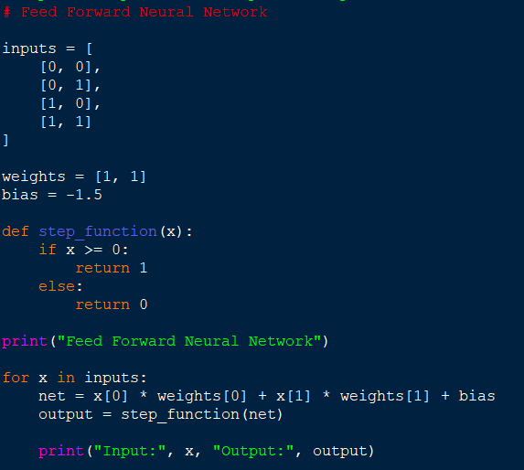

Output

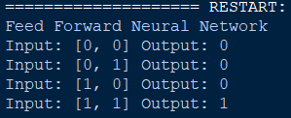

Result
The python program to implement feed forward neural network was successfully designed as per the stated objective. The required output can be obtained by executing the corresponding program with valid input.

17. Prolog program to Sum the Integers from 1 to n

Aim
To calculate the sum of integers from 1 to n in Prolog.

Algorithm
- Read the value of n.
- Use a base case for n=0.
- For n>0, recursively calculate the sum for n-1.
- Add n to the recursive result.
- Return the final sum.

Pseudocode
START
Read the value of n.
Use a base case for n=0.
For n>0, recursively calculate the sum for n-1.
Add n to the recursive result.
Return the final sum.
DISPLAY the required result
STOP

Output

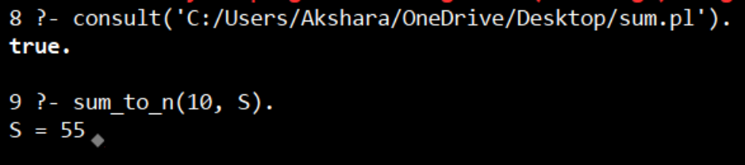

Result
The prolog program to sum the integers from 1 to n was successfully designed as per the stated objective. The required output can be obtained by executing the corresponding program with valid input.

18. Prolog program for a database with NAME, DOB

Aim
To store and retrieve person names and dates of birth using a Prolog database.

Algorithm
- Define facts containing name and date of birth.
- Create a query predicate if required.
- Consult the Prolog file.
- Query a name or date.
- Display matching facts.

Pseudocode
START
Define facts containing name and date of birth.
Create a query predicate if required.
Consult the Prolog file.
Query a name or date.
Display matching facts.
DISPLAY the required result
STOP

Output

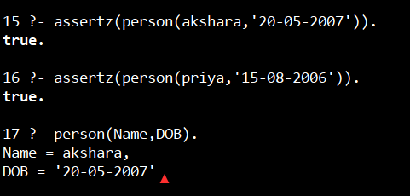

Result
The prolog program for a database with name, dob was successfully designed as per the stated objective. The required output can be obtained by executing the corresponding program with valid input.

19. Prolog program for STUDENT-TEACHER-SUB-CODE

Aim
To represent the relationship among students, teachers and subject codes.

Algorithm
- Define facts for students, teachers and subject codes.
- Define relationships among the facts.
- Create a query predicate.
- Enter a student, teacher or code query.
- Display matching relationships.

Pseudocode
START
Define facts for students, teachers and subject codes.
Define relationships among the facts.
Create a query predicate.
Enter a student, teacher or code query.
Display matching relationships.
DISPLAY the required result
STOP

Output

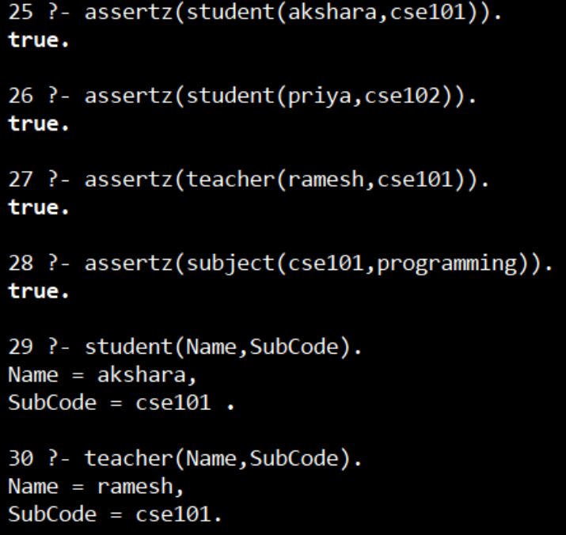

Result
The prolog program for student-teacher-sub-code was successfully designed as per the stated objective. The required output can be obtained by executing the corresponding program with valid input.

20. Prolog program for PLANETS DB

Aim
To create a Prolog knowledge base containing planet information.

Algorithm
- Define planet facts with relevant attributes.
- Load the Prolog file.
- Define a predicate for displaying or querying planets.
- Enter a query.
- Display the matching planet information.

Pseudocode
START
Define planet facts with relevant attributes.
Load the Prolog file.
Define a predicate for displaying or querying planets.
Enter a query.
Display the matching planet information.
DISPLAY the required result
STOP

Output

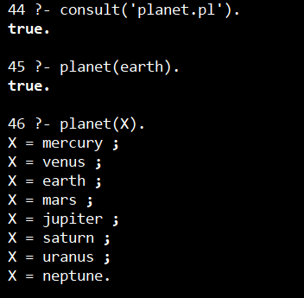

Result
The prolog program for planets db was successfully designed as per the stated objective. The required output can be obtained by executing the corresponding program with valid input.
21. Prolog program to implement Towers of Hanoi

Aim
To solve the Towers of Hanoi problem using Prolog recursion.

Algorithm
- For one disk, move it directly.
- Move n-1 disks from source to auxiliary.
- Move the largest disk to destination.
- Move n-1 disks from auxiliary to destination.
- Repeat recursively until complete.

Pseudocode
START
For one disk, move it directly.
Move n-1 disks from source to auxiliary.
Move the largest disk to destination.
Move n-1 disks from auxiliary to destination.
Repeat recursively until complete.
DISPLAY the required result
STOP

Output

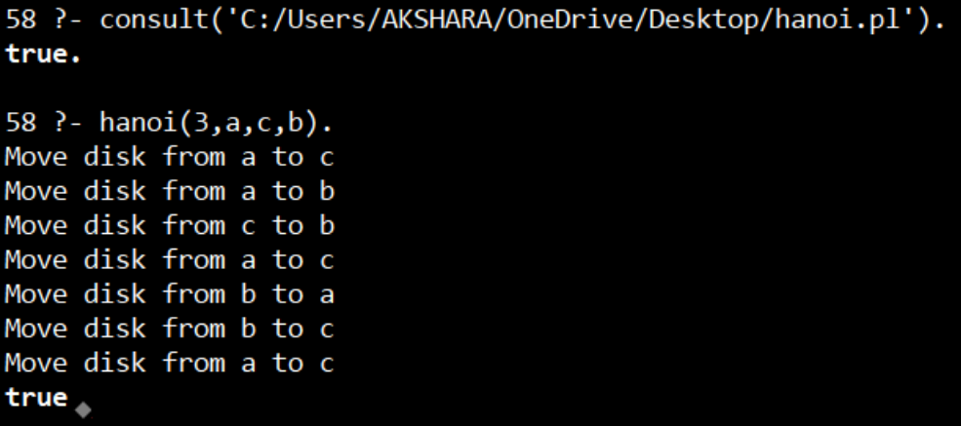

Result
The prolog program to implement towers of hanoi was successfully designed as per the stated objective. The required output can be obtained by executing the corresponding program with valid input.

22. Prolog program to print particular bird can fly or not; incorporate required queries

Aim
To determine whether a selected bird can fly using Prolog facts and rules.

Algorithm
- Define bird facts and flying rules.
- Load the knowledge base.
- Query the selected bird.
- Apply the rule if its conditions are satisfied.
- Return whether the bird can fly.

Pseudocode
START
Define bird facts and flying rules.
Load the knowledge base.
Query the selected bird.
Apply the rule if its conditions are satisfied.
Return whether the bird can fly.
DISPLAY the required result
STOP

Output

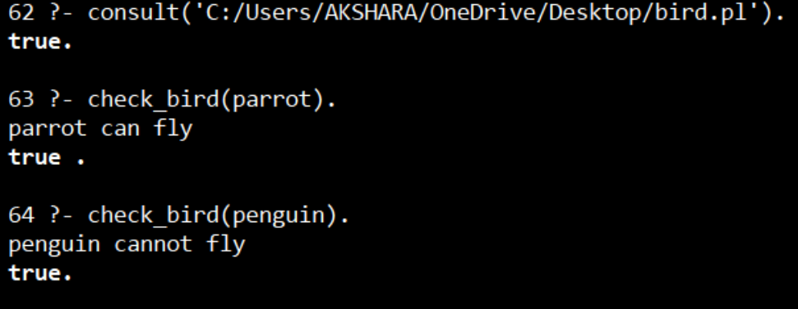

Result
The prolog program to print particular bird can fly or not; incorporate required queries was successfully designed as per the stated objective. The required output can be obtained by executing the corresponding program with valid input.

23. Prolog program to implement family tree

Aim
To represent family relationships and answer family-tree queries.

Algorithm
- Define parent facts.
- Derive relationships such as sibling, grandparent or child using rules.
- Load the program.
- Query a relationship.
- Display all valid answers.

Pseudocode
START
Define parent facts.
Derive relationships such as sibling, grandparent or child using rules.
Load the program.
Query a relationship.
Display all valid answers.
DISPLAY the required result
STOP

Output

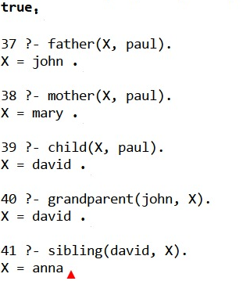

Result
The prolog program to implement family tree was successfully designed as per the stated objective. The required output can be obtained by executing the corresponding program with valid input.

24. Prolog program to suggest Dieting System based on Disease

Aim
To suggest a suitable diet based on a disease entered by the user.

Algorithm
- Define disease facts and corresponding diet suggestions.
- Read the disease query.
- Match the disease with the knowledge base.
- Retrieve the associated suggestion.
- Display the result.

Pseudocode
START
Define disease facts and corresponding diet suggestions.
Read the disease query.
Match the disease with the knowledge base.
Retrieve the associated suggestion.
Display the result.
DISPLAY the required result
STOP

Output
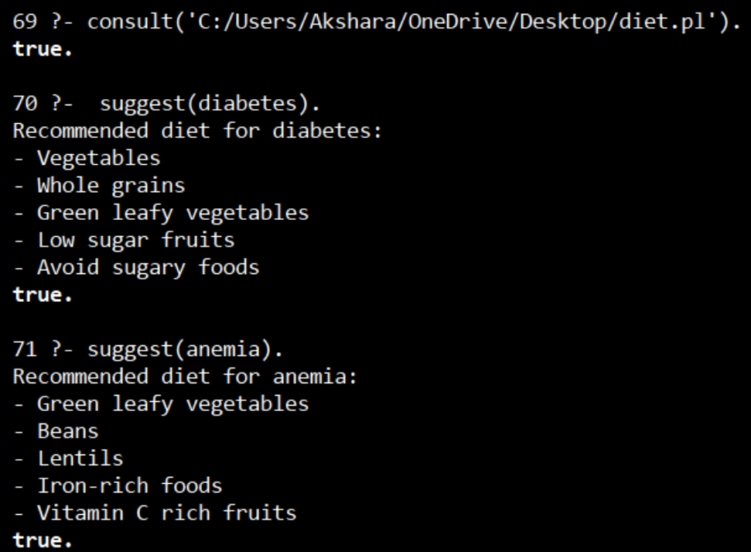

Result
The prolog program to suggest dieting system based on disease was successfully designed as per the stated objective. The required output can be obtained by executing the corresponding program with valid input.

25. Prolog program to implement Monkey Banana Problem

Aim
To solve the Monkey Banana problem using state-space search.

Algorithm
- Represent monkey position, box position, banana position and object status.
- Generate valid actions such as move, push, climb and take.
- Update the state after each action.
- Avoid invalid or repeated states.
- Continue until the banana is obtained.

Pseudocode
START
Represent monkey position, box position, banana position and object status.
Generate valid actions such as move, push, climb and take.
Update the state after each action.
Avoid invalid or repeated states.
Continue until the banana is obtained.
DISPLAY the required result
STOP

Output

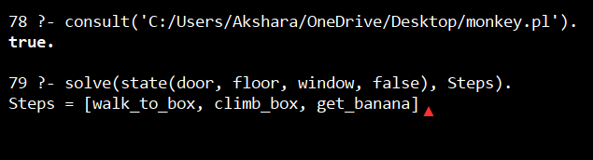

Result
The prolog program to implement monkey banana problem was successfully designed as per the stated objective. The required output can be obtained by executing the corresponding program with valid input.

26. Prolog program for fruit and its color using Back Tracking

Aim
To determine the color of a fruit using Prolog backtracking.

Algorithm
- Store fruit-color facts.
- Query a fruit.
- Match the query with facts.
- Use backtracking to find additional matching facts if available.
- Display the color results.

Pseudocode
START
Store fruit-color facts.
Query a fruit.
Match the query with facts.
Use backtracking to find additional matching facts if available.
Display the color results.
DISPLAY the required result
STOP

Output

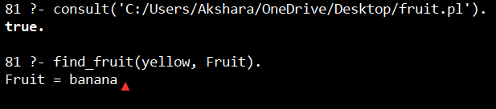

Result
The prolog program for fruit and its color using back tracking was successfully designed as per the stated objective. The required output can be obtained by executing the corresponding program with valid input.

27. Prolog program to implement Best First Search algorithm

Aim
To find a goal node using Best First Search.

Algorithm
- Initialize the open list with the start node.
- Assign heuristic values.
- Select the node with the best heuristic value.
- Expand it and add eligible successors.
- Repeat until the goal is found or the list is empty.

Pseudocode
START
Initialize the open list with the start node.
Assign heuristic values.
Select the node with the best heuristic value.
Expand it and add eligible successors.
Repeat until the goal is found or the list is empty.
DISPLAY the required result
STOP

Output

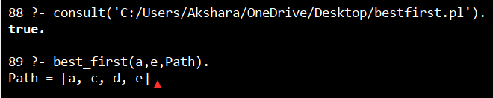

Result
The prolog program to implement best first search algorithm was successfully designed as per the stated objective. The required output can be obtained by executing the corresponding program with valid input.

28. Prolog program for Medical Diagnosis

Aim
To diagnose a medical condition using Prolog facts and rules.

Algorithm
- Define symptoms and diagnosis rules.
- Accept symptoms as query information.
- Match symptoms against rules.
- Infer the possible diagnosis.
- Display the matching diagnosis.

Pseudocode
START
Define symptoms and diagnosis rules.
Accept symptoms as query information.
Match symptoms against rules.
Infer the possible diagnosis.
Display the matching diagnosis.
DISPLAY the required result
STOP

Output

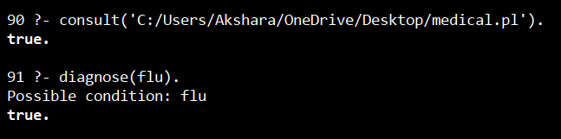

Result
The prolog program for medical diagnosis was successfully designed as per the stated objective. The required output can be obtained by executing the corresponding program with valid input.

29. Prolog program for forward Chaining; incorporate required queries

Aim
To implement forward chaining from known facts toward a conclusion.

Algorithm
- Store initial facts and rules.
- Select rules whose premises are satisfied.
- Add their conclusions as new facts.
- Repeat until the goal is derived or no new fact can be added.
- Query the resulting conclusion.

Pseudocode
START
Store initial facts and rules.
Select rules whose premises are satisfied.
Add their conclusions as new facts.
Repeat until the goal is derived or no new fact can be added.
Query the resulting conclusion.
DISPLAY the required result
STOP

Output

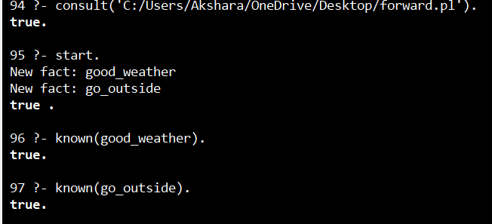

Result
The prolog program for forward chaining; incorporate required queries was successfully designed as per the stated objective. The required output can be obtained by executing the corresponding program with valid input.

30. Prolog program for backward Chaining; incorporate required queries

Aim
To implement backward chaining by working from a goal toward supporting facts.

Algorithm
- Start with the required goal.
- Find rules that can conclude the goal.
- Treat their premises as subgoals.
- Recursively prove the subgoals from facts or other rules.
- Return success when all required premises are proven.

Pseudocode
START
Start with the required goal.
Find rules that can conclude the goal.
Treat their premises as subgoals.
Recursively prove the subgoals from facts or other rules.
Return success when all required premises are proven.
DISPLAY the required result
STOP

Output

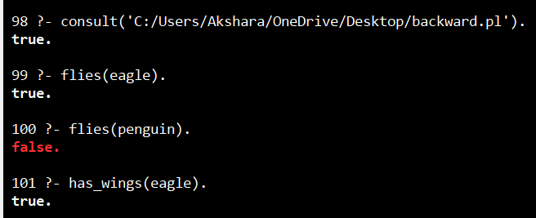

Result
The prolog program for backward chaining; incorporate required queries was successfully designed as per the stated objective. The required output can be obtained by executing the corresponding program with valid input.

31. Create a Web blog using WordPress to demonstrate Anchor Tag, Title Tag, etc.

Aim
To create a WordPress web blog demonstrating basic HTML/web concepts such as anchor and title tags.

Algorithm
- Create or open a WordPress site.
- Create a page or post.
- Add a suitable title.
- Insert links using anchor elements where HTML editing is available.
- Publish and verify the displayed links and title.

Pseudocode
START
Create or open a WordPress site.
Create a page or post.
Add a suitable title.
Insert links using anchor elements where HTML editing is available.
Publish and verify the displayed links and title.
DISPLAY the required result
STOP

Result
The create a web blog using wordpress to demonstrate anchor tag, title tag, etc. was successfully designed as per the stated objective. The required output can be obtained by executing the corresponding program with valid input.

32. Prolog program to implement pattern matching

Aim
To implement pattern matching in Prolog.

Algorithm
- Define a pattern and input structure.
- Compare corresponding elements.
- Check whether variables can be consistently bound.
- Use recursion for lists or nested structures.
- Return success for a matching pattern and failure otherwise.

Pseudocode
START
Define a pattern and input structure.
Compare corresponding elements.
Check whether variables can be consistently bound.
Use recursion for lists or nested structures.
Return success for a matching pattern and failure otherwise.
DISPLAY the required result
STOP

Output

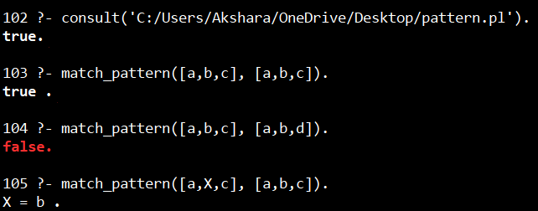

Result
The prolog program to implement pattern matching was successfully designed as per the stated objective. The required output can be obtained by executing the corresponding program with valid input.

33. Prolog program to find the number of vowels

Aim
To count the number of vowels in a word or string using Prolog.

Algorithm
- Read the input characters.
- Check each character against a,e,i,o,u.
- Increment the count when a vowel is found.
- Continue until all characters are processed.
- Return the total vowel count.

Pseudocode
START
Read the input characters.
Check each character against a,e,i,o,u.
Increment the count when a vowel is found.
Continue until all characters are processed.
Return the total vowel count.
DISPLAY the required result
STOP

Output

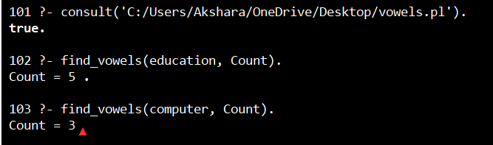

Result
The prolog program to find the number of vowels was successfully designed as per the stated objective. The required output can be obtained by executing the corresponding program with valid input.

